

AMERICAN INTERNATIONAL UNIVERSITY–BANGLADESH (AIUB)
Dept. of Computer Science
Faculty of Science and Technology
CSC2210: OBJECT ORIENTED PROGRAMMING 2
Spring 2024-2025
Section: [P]
Group No: 052

Project Report On
Project Name: [Saloon Management System]
Supervised By
Mehedi Hasan

Submitted By:
Name | ID
Wakar Alvee | 23-51784-2
Md Rafit | 23-50418-1
Ashiqur Rahman Ashik | 23-50734-1
Mehedi Hasan Soaib | 23-51621-2

Obtained Marks for CO2 and CO3 (Description given in the following page)
Assessment  Criteria | Not Attended/ Incorrect (0) |  | Inadequate  (1-2) |  | Average  (3) | Good  (4) | Excellent  (5)
Evaluation Criteria (CO2) |  | Total = |  | Evaluation Criteria (CO3) |  |  | Total =
Requirement fulfillment |  |  |  | Organization of the application
Validation |  |  |  | Representation and Integration of Database
Verification |  |  |  | Graphical User Interface

CO2: Display and verify the mean of a real-life Project using the concepts of C# Graphical User Interface based environment with database integration to depict a desktop-based application.
Assessment  Criteria | Not Attended/ Incorrect (0) | Inadequate  (1-2) |  | Average  (3) |  | Good  (4) |  | Excellent  (5)
Evaluation Criteria | Evaluation Definition
Requirement fulfillment | Fails to demonstrate any understanding of real-life scenario-based project development or functional requirement identification. There is no attempt to depict a project or identify functional requirements accurately. |  | Demonstrates limited understanding of real-life scenario-based project development and functional requirement identification. The project depicted lacks coherence or relevance to real-life scenarios, and functional requirements are inaccurately identified or insufficiently described. |  | Presents a basic depiction of a real-life scenario-based project and identifies some functional requirements. However, the project lacks depth or complexity, and some functional requirements may be vaguely defined or missing key details. |  | Effectively demonstrates a realistic scenario-based project and accurately identifies most functional requirements. The project is well-developed with appropriate complexity, and functional requirements are clearly articulated with relevant details. |  | Exhibits an exceptional understanding of real-life scenario-based project development and accurately identifies all functional requirements. The project is meticulously developed with thorough attention to detail, reflecting a comprehensive understanding of Object-Oriented Programming project development activities.
Validation | Fails to demonstrate any understanding or implementation of validation forms in their system. There is no attempt to deal with data validation, and validation requirements are completely ignored or incorrectly applied. |  | Demonstrates limited understanding of validation forms and data validation techniques. While some attempt may be made to implement validation, it is incomplete or poorly executed, leading to inadequate handling of data validation. |  | Shows a basic understanding of validation forms and data validation techniques. They attempt to implement validation, but some aspects may be missing or incorrectly implemented, resulting in partial or inconsistent handling of data validation. |  | Effectively demonstrates the use of validation forms and implements data validation techniques. Validation is mostly accurate and comprehensive, ensuring the proper handling of data input and verification in the system. |  | Exhibits an exceptional understanding and implementation of validation forms and data validation techniques. Validation is meticulously implemented with thorough attention to detail, ensuring robust data validation procedures and contributing to the overall reliability and integrity of the system.
Verification | Fails to demonstrate any attempt to verify the system data or functional requirements. There is no evidence of understanding or implementation of verification processes, and data flow is not considered. |  | Demonstrates limited understanding of verification processes and data flow in the system. Verification attempts are incomplete or inaccurate, and there is insufficient consideration given to ensuring data integrity and functionality. |  | Shows a basic understanding of verification processes and attempts to verify system data. However, verification efforts may be inconsistent or lack thoroughness, and there may be gaps in ensuring proper functional requirements and data flow. |  | Identifies and verifies system data, ensuring proper functional requirements are met. Verification efforts are mostly accurate and thorough, with attention to ensuring data integrity and appropriate data flow within the system. |  | Exhibits an exceptional understanding of verification processes and meticulously verifies system data. Verification efforts are comprehensive and precise, with a keen focus on ensuring all functional requirements are met and maintaining proper data flow throughout the system.

CO3: Prepare and Explain a real life desktop based application synthesizing several component of C# along with development tools to adhere the given requirements.
Assessment  Criteria | Not Attended/ Incorrect (0) | Inadequate  (1-2) |  | Average  (3) |  | Good  (4) |  | Excellent  (5)
Evaluation Criteria | Evaluation Definition
Organization of the application | Fails to identify any suitable real time application or requirements for project development activities related to OOP. |  | Limited understanding about the project scopes and scenarios or identification of functional requirements. |  | Lacks depth or relevance to OOP project development activities and may contain inaccuracies. Real-life scenarios are mentioned, but the discussion lacks depth or clarity. |  | Consider and integrate the idea of several core aspects of the project along with relevance to real-life scenarios. Demonstrating a solid understanding of the application presentation. |  | Generalize and exhibits an exceptional understanding of project preparation according to a to real-life scenarios. Also contains proper and insightful identification of the system which is comprehensive and precise.
Representation and Integration of Database | Fails to identify and present any understanding or implementation of database. Also failed to integrate the data with the project itself. |  | Limited understanding of the database concepts or their proper way of using in a real time project. While some attempt may be made to implement but it is incomplete or poorly executed, leading to inadequate design. |  | Lacks depth or relevance to database integration with the application. Shows a basic understanding but some aspects may be missing or incorrectly implemented, resulting in partial or inconsistency. May lack proper normalization. |  | Integrate the database with the forms properly and implements it with proper validation which is mostly accurate and comprehensive, ensuring the proper handling of data input and verification along with general normalization. |  | Exhibits an exceptional understanding and implementation of database ensuring attention to detail, and robust data manipulation procedures and contributing to the overall clarity.
Graphical User Interface | Fails to present or prepare GUI based application interfaces. There is no evidence of creating or integrating such things according to their usefulness. |  | Limited understanding of graphical user interfaces. Lack of design knowledge. Very poor attempt to make such things which are currently obsolete or can’t be identified as coherent. |  | Shows a basic understanding of creating user interfaces. Most of them are interconnected but maybe some of them lack it. However, most of it can be described as user friendly. |  | Effectively identifies and meet the consider the simplicity. Design related works are mostly accurate and taken proper attention to ensuring a user-friendly coherent system. |  | Exhibits an exceptional work design following a high standard of simple and elegant work. Several controls and mechanism has been organized in a preferred way according to the coherent usage .

Table of Contents:

1. Chapter: 01 (Introduction)
2. Chapter: 02 (Scenario Description)
3. Chapter: 03 (ER Diagram)
4. Chapter: 04 (Feature List)
5. Chapter: 05 (Form Design)
6. Chapter: 06 (UML Diagram)
7. Chapter: 07 (Use Case Diagram)
8. Chapter: 08 (Schema Diagram)
9. Chapter: 09 (Conclusion)

Introduction: As we are in the age of digitization now, businesses rely more on software solutions to operate day-to-day operations more efficiently. To address this need for the salon business, we developed a desktop application to simplify salon operations through a role-based management system. The system is modeled to replicate real-life roles in a salon, including managers, barbers, and salespersons, with different levels of access and operations. The application begins with a secure login form that redirects users to role-based dashboards—Admin, Barber 1, or Barber 2—based on their credentials. Administrators have full access, with the option to control service packages and view all customer records, while barbers have restricted access to processing customer orders only. This structured access ensures that users can only perform tasks relevant to their roles, which helps protect data and maintain accountability. The project effectively demonstrates how practical salon procedures can be computerized in a simple, secure, and user-friendly way.

Scenario Description: In today’s fast-paced world, salons need more than just scissors and style—they need smart systems. That’s why we developed a user-friendly desktop application to streamline salon operations with a powerful role-based access system.
The app opens with a secure login screen, directing users to different dashboards based on their roles: Admin (Manager), Barber 1, or Barber 2. Each role is tailored to match real-life responsibilities inside the salon.
Admin has full control—managing service packages, tracking sales, and accessing customer history through dynamic modules.
Barbers get a clean interface where they can view packages, assist clients, and confirm orders, which are saved in separate records for easy tracking.
Sales staff can flexibly operate under either barber role, allowing smooth support during busy hours.
With distinct access levels and organized data storage, the app ensures efficiency, accountability, and data security—all while giving the salon a modern digital makeover.

ER Diagram:
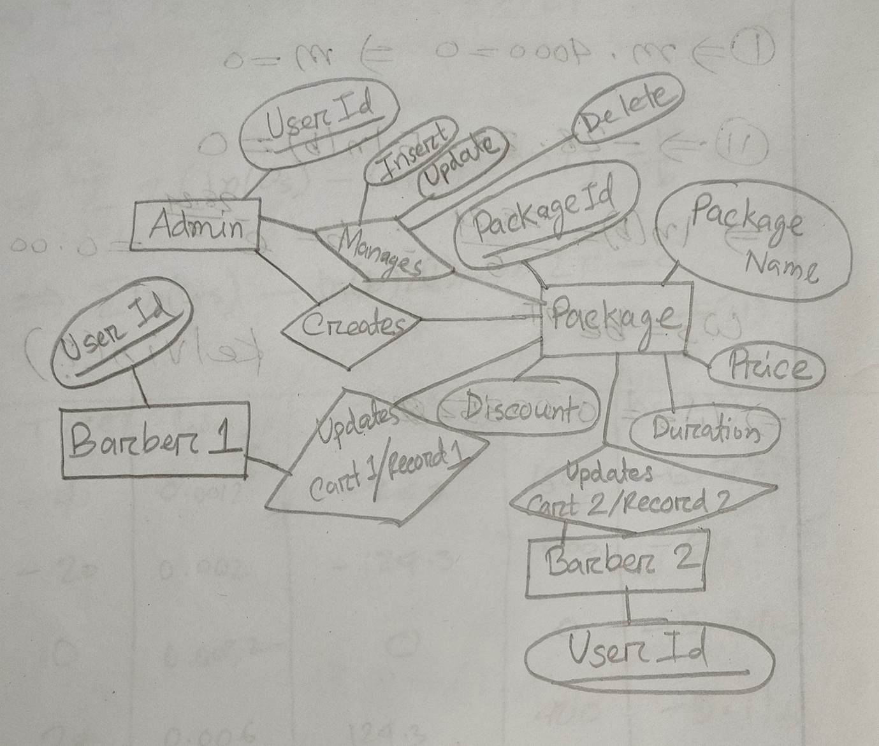
Feature List :
Login & Role Management
- Secure login screen with user ID and password.
- Role-based redirection: Admin, Barber 1, Barber 2.
- Salesman can log in as either Barber 1 or Barber 2.
- Role-specific access control to prevent unauthorized usage.
Admin Features
- Full CRUD access to all core modules.
- Manage Service Packages: Add, edit, delete package details (ID, Name, Price, Discount).
- Access Record Tables:
  - Record Table 1 (Barber 1’s customer history).
  - Record Table 2 (Barber 2’s customer history).
- Monitor barber activities and customer orders.
- Maintain service pricing and discount updates in real-time.
Barber Features (Barber 1 & Barber 2)
- View list of available service packages.
- Assist customers in selecting packages.
- Add selected services to a Cart View.
- Confirm or cancel orders.
- Save confirmed orders to respective record table (Barber 1 → Table 1, Barber 2 → Table 2).
- Return to login screen anytime.
Cart & Order Handling
- Dynamic cart system for selected services.
- Options to confirm, cancel, or edit orders before submission.
- Auto-save of confirmed orders to specific record tables.
Data Separation & Tracking
- Individual record tables for each barber.
- Accurate tracking of which barber handled each customer.
- Supports performance analysis and accountability.
Security & Integrity
- Role-specific access ensures data privacy.
- Prevents users from accessing unauthorized modules.
- Supports clean separation between administrative and service duties.

Form Design:
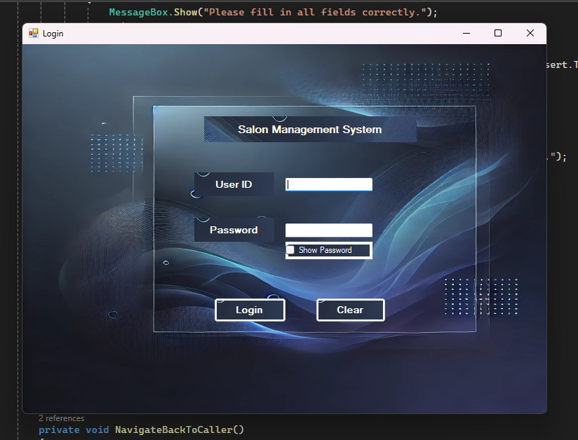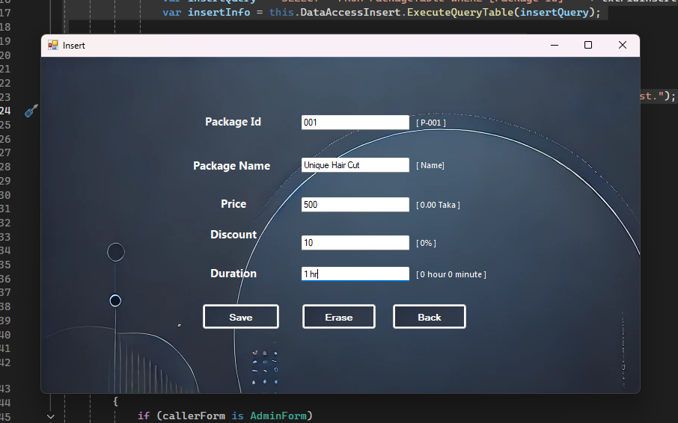
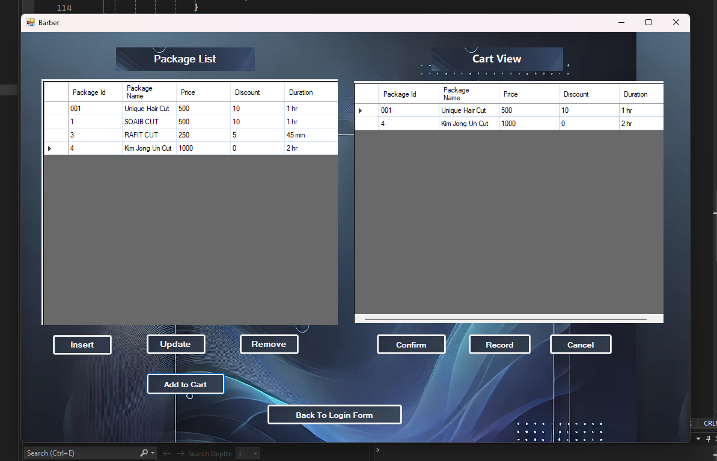
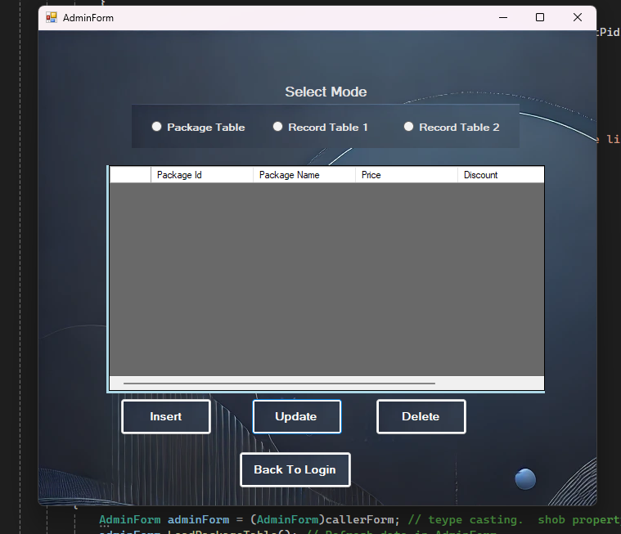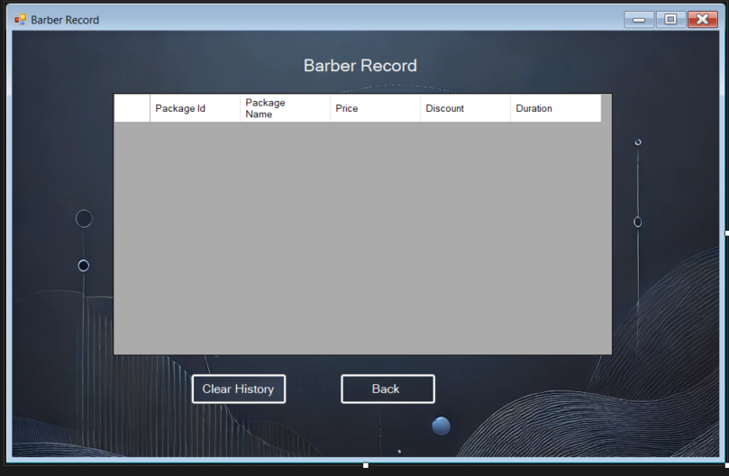

UML Diagram:
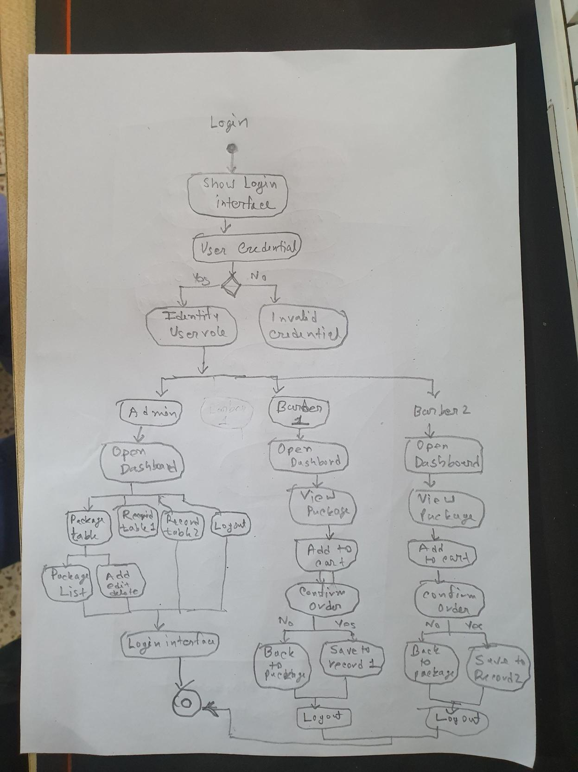

Use Case Diagram:
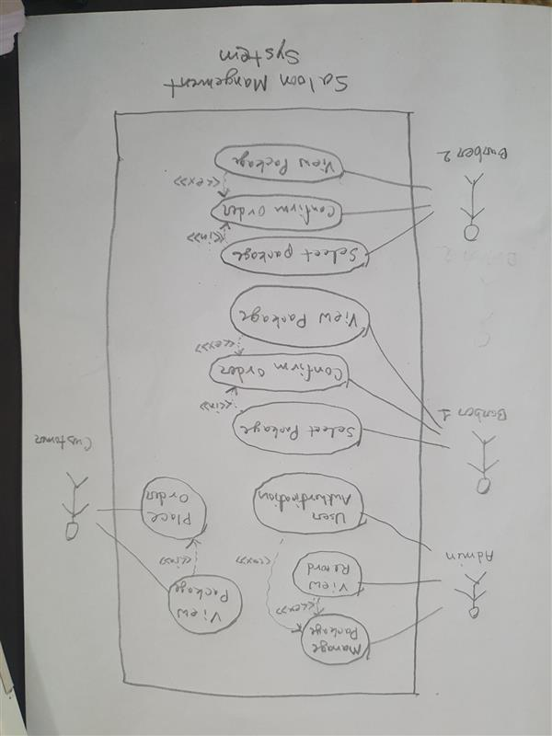

Schema Diagram:
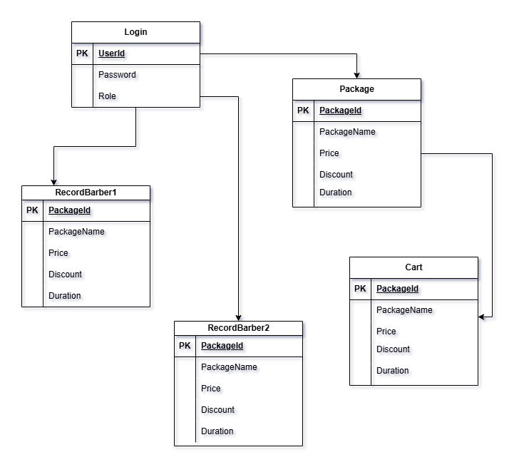

Conclusion: The desktop software computerizes salon operations efficiently through a well-structured, role-based management system. Through different permissions for Admins, Barbers, and support staff, the system mimics real-world workflows while ensuring security, accountability, and efficiency. With the integration of service package management, customer order tracking, and role-based dashboards, day-to-day operations are simplified and streamlined. The tool not only enhances operational effectiveness but also provides a scalable solution for future automation and performance metrics in the salon environment. Lastly, it is an executable solution for revolutionizing traditional service-based businesses.

